**Quiz for Java Programming** (Tutor: cyd@bupt.edu.cn)

Unit03-Inheritance and Polymophism

1. A parent class is also called superclass class in java and a child class is called subclass class
2. Keyword "super" may be used to call a superclass constructor or a superclass method
3. In C++ inheritance, the child class may call the parent class's ctor by : PrarentClassCtr .
4. T[T/F] "super" may appear anywhere in the subclass's method body.
5. T[T/F] No matter if we explicit give a ctor, the compiler will generate a default ctor.
6. T[T/F] A non-private static method in super class can be inherited and overrided by its subclass .
7. T[T/F] Both C++ and java classes are derived from the Object class.
8. T[T/F] An initialization block is executed as if it were placed at the beginning of every constructor in the class
9. Write a class Robot, which has a name and may move(steps) , turnLeft(), turnRight() and getPosition(). getPosition() returns an object which holds the coordinates. It also needs a directional status (which are south, north, east or west). Write a sub class SmartRobot, which has a two-dimensional array to record each step.

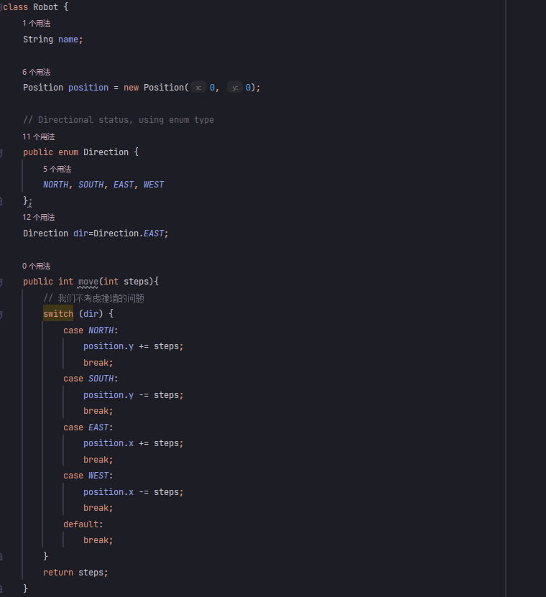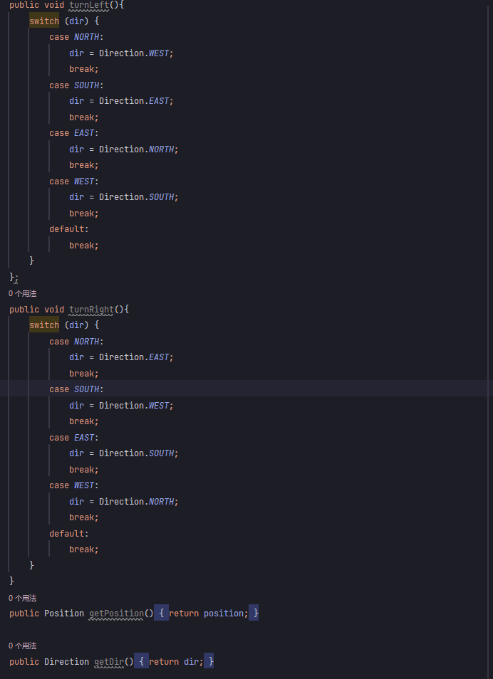

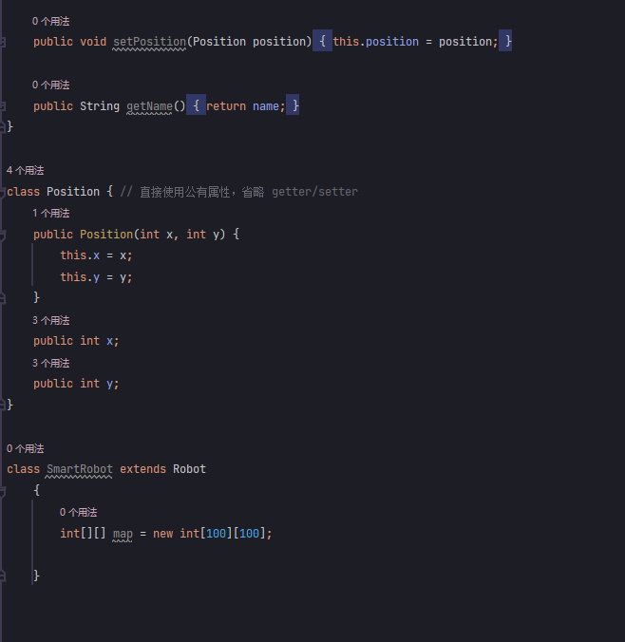

1. Based on Quiz 9, finish the superclass's ctor(s) and the subclass's ctors. One of the subclass's ctor need to call another ctor to set the initial direction.

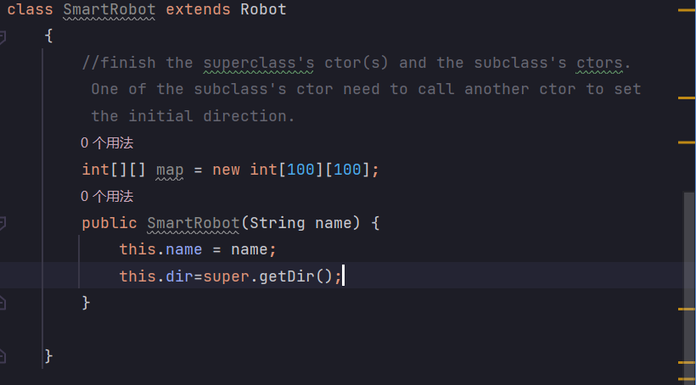

1. Based on Quiz10, override the methods of Robot in SmartRobot class, which may record the path that the SmartRobot object moves.

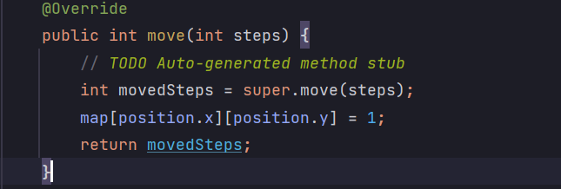

1. Based on Quiz11, override toString() in Robot to output its coordinates and toString() in SmartRobot classes to output its path. In main(), test these two toString() methods.

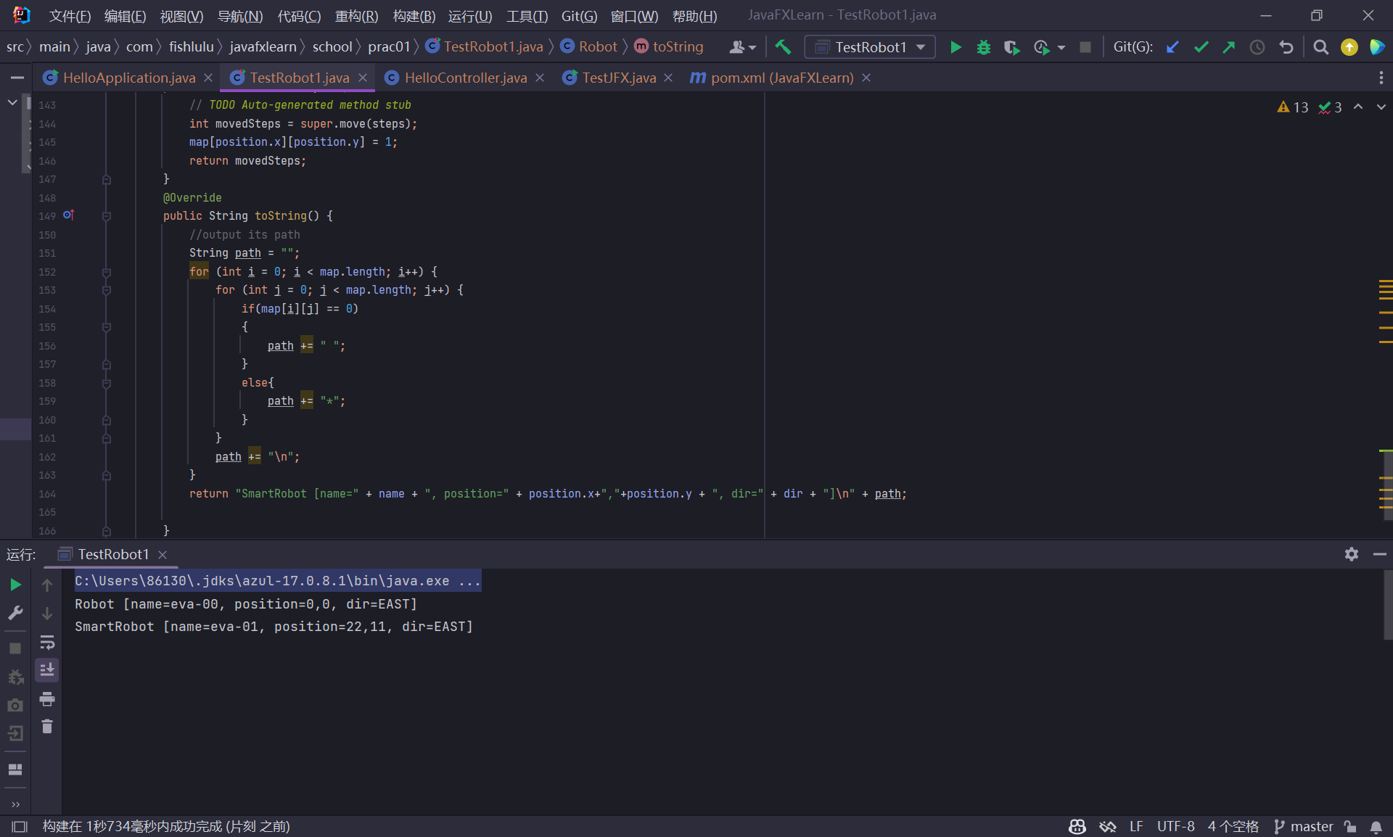

1. Based on Quiz 12, in main(), create at least one Robot object and one SmartRobot object and assign all these objects to a Robot array. Call the methods of Robot and SmartRobot objects by the Robot array and output the coordinates or paths.

